**NMS- Unified Network Management Solution**

Unified Network Management Solution

UNMP is a robust and scalable platform for configuring and monitoring of the based devices present in any enterprise as well as carrier grade network. UNMS automatically detects and provisions the newly installed network elements, with the option of profiling and grouping the desired configurations. Any number of devices can be deployed in up and running state within no time, on a turnkey basis. UNMS not only provides the central monitoring but also the core management of all the network devices, thereby acting as an efficient EMS for all the SHYAM data products as well. Platform has full-fledged framework to monitor and log comprehensive report on network and performance of device and services.

UNMP provides interface for alert management, includes alert forwarding, alert masking, hierarchical alert management, alert notification medium management i.e mail, sms, jabber etc, alarm scheduling and more. Additionally, UNMS can automatically escalate network alerts until a problem is resolved. UNMP’s Conditional Group Dependencies allows you to intelligently group connected devices and/or interfaces together, these dependencies allows NMS to generate only a limited number of intelligent alerts. UNMP provides automatically generated network maps, displaying network topology, so that user can always pin point the network element that needs attention.

Reports management is the highlighted feature of the UNMP, where user can get predefined reports for network elements or services or alerts and also provides an interface to create and save desired reports from the scratch.

UNMP’s dashboards gives a unified view into the performance of thousands of nodes and interfaces on your network, all from a single web page, where you can drill into any element to see exactly what's happening. Dashboards are completely customizable as per the user requirement with additional unified dashboards for device-types, devices, device services and so on.

UNMP also keeps track of user activity over the network elements, if any configuration being set by the user creates network issues, admin can always trace back the last stable configuration of the element and revert the current configuration.

Multiple interfaces are provided by the UNMP for the easy third party integration, i.e north bound interface, commonly used are SNMP, CORBA and XML-RPC.

UNMS is a powerful, proactive monitoring and management solution, it's tried, tested, and proven on networks just like yours – over 10000 of them. UNMS ensures you have 360° visibility, actionable intelligence and complete control to make not only fast decisions, but better ones.

## Key Features

* Realtime centralized monitoring of all IP-based devices
* Centralized configuration of all IP-based devices
* Scalability, small to large distributed monitoring
* Automated creation of network topology map
* Heirarchial notification system
* Automatic discovery of network elements
* Web based User Interface
* Automated and scheduled backup and data reconciliation
* Support for both, Agent based and Agent less monitoring
* Reporting and treanding
* Extendable Architecture
* North Bound Interface

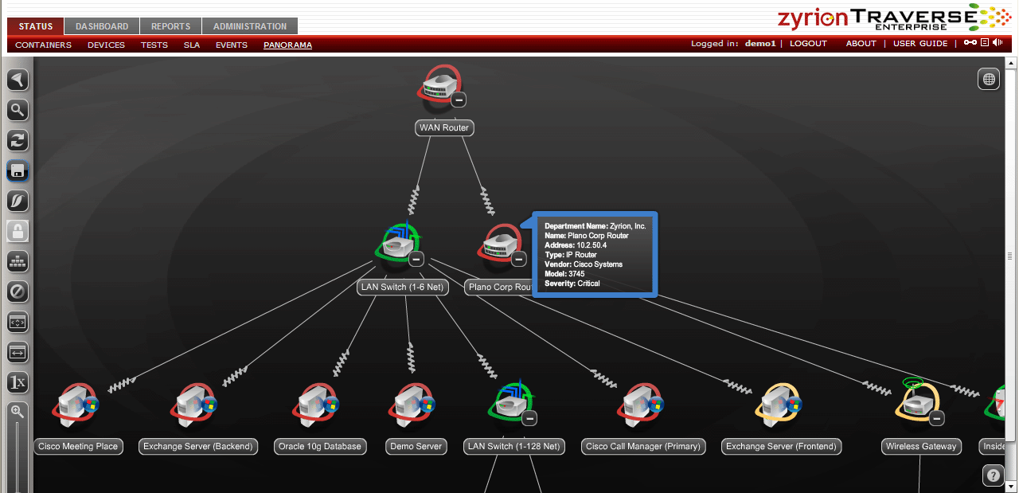

|  |
| --- |
| **Accounting & Authentication** |
| **Web Based** |
| **RADIUS with failover and load balancing** |
| **MAC whitelisting/blacklisting** |
| **802.1x Based**  LEAP, PEAP, EAP-TLS, EAP-TTLS, EAP-SIM, EAP-AKA  TKIP and AES encryption, WEP |

|  |
| --- |
| **Server System Requirement** |
| **Server Operating System**  Linux Kernel 2.4 +, preferably Ubuntu 10.10 |
| **Server Hardware**  2 Ghz + CPU, 2 GB + RAM |
| **Server Storage**  60 GB |

|  |
| --- |
| **Network Graphs and Maps** |
| **Google Maps Integration** |
| **RRD based graphs**  MRTG, PNP4Nagios, Nagvis Maps |
| **Network Topology Maps**  Proprietary Network Element Topology Plugin |

|  |
| --- |
| **Scalability** |
| **At Max 1000 devices per site** |
| **Max 100 sites per installation** |
| **Max User Database of 2000 users** |
| **Max 10 Remote installations and integration with central server** |

|  |
| --- |
| **North Bound** |
| **XML/SOAP based web services**  Simple Object Access Protocol |
| **SNMP North Bound**  Simple Networ Managemet Protocol |
| **CORBA**  Common Object Request Broker Architecture |
| **JMQ ( Java Message Queuing)** |

|  |
| --- |
| **Network Graphs and Maps** |
| **Google Maps Integration** |
| **RRD based graphs**  MRTG, PNP4Nagios |
| **Network Topology Maps**  Proprietary Network Element Topology Plugin |

|  |
| --- |
| **Management** |
| **Role-based administration** |
| **VPN for secure remote access** |
| **Profile Management** Common configurationprofile for RU, TU, AP, CPE, Switch, IP cameras |
| **Multisite Management** Centralized management of multiple networks |
| **Web-based management** Plugins for device andcentral UNMP management |
| **Inventory Management** Auto-provisioning of devices |

|  |
| --- |
| **Monitoring** |
| **SNMP Monitoring** |
| **Alarm Management** History of upto 1,00,000 alarms |
| **Generic Device Monitoring** SNMP, HTTP, PING, ICMP, IGMP, FTP, Processor Load, Swap, DHCP, TCP, UDP, Telnet, HTTPS, IMAP, SMTP, monitoring |
| **Dashboards** Common Dashboard for All devices, Device-type Dashboards, User Favorite Resources Dashboards, Device Service Dashboards, Alerts and Errors Dashboards, User Trail Dashboards, Device Detailed Dashboards |
| **Performance Monitoring** CRC Errors  PHY Errors  RSSI  Freq channel and Bandwidth Tx-Rx packet  Radio Frame Level  Modulation |

|  |
| --- |
|  |

**ABOUT SHYAM NETWORKS LIMITED**

Shyam Networks provides state-of-the-art networking and security solutions for diverse corporate enterprises, governments, educational institutions, offices and residences. From high end enterprise network solutions and wireless broadband connectivity to simple broadband access for homes, we ensure speed, capacity and range for both outdoor and indoor applications. We understand your networking needs as they evolve in a dynamic environment and manage them with cost effective, innovative answers.

Shyam Networks offers end-to-end solutions for homeland security, industrial security, and mission critical, sensitive sectors. We also offer a range of products that bring you an enhanced internet experience, in dense urban locations or remote rural areas where power and infrastructure are unreliable. Shyam Networks has networking solutions to connect subscribers in even the most challenging environments.

© 2011 Shyam Networks Limited | All rights reserved

Shyam Networks Limited assumes no responsibility for any inaccuracies in this document.

Shyam Networks Limited reserves the right to revise this document without notice.

SNL/RECON/01/PA1

**CONTACT US**

21-22, Phase IV, Udyog Vihar,

Gurgaon 122015 Haryana, India

Phone: +91 124 395 9200-04

Fax: +91 124 395 9205

Email: [sales@shyamnetworks.com](mailto:sales@shyamnetworks.com)

**http://www.shyamnetworks.com**